**Lab 4 Report:**

Created my own data set and implemented Naive Bayes classification algorithm on my data set.

Below is the **Confusion Matrix** for my Training Data.Naive Bayes algorithms splits training data into test data and implements algorithm

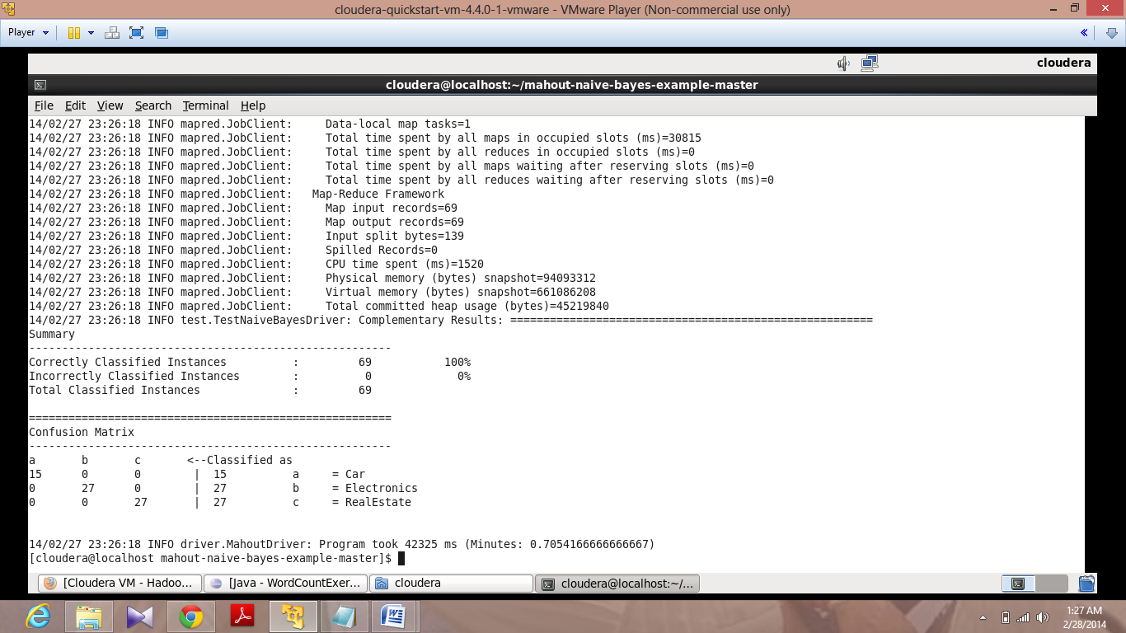

Below is the **Confusion Matrix** for my Test Data

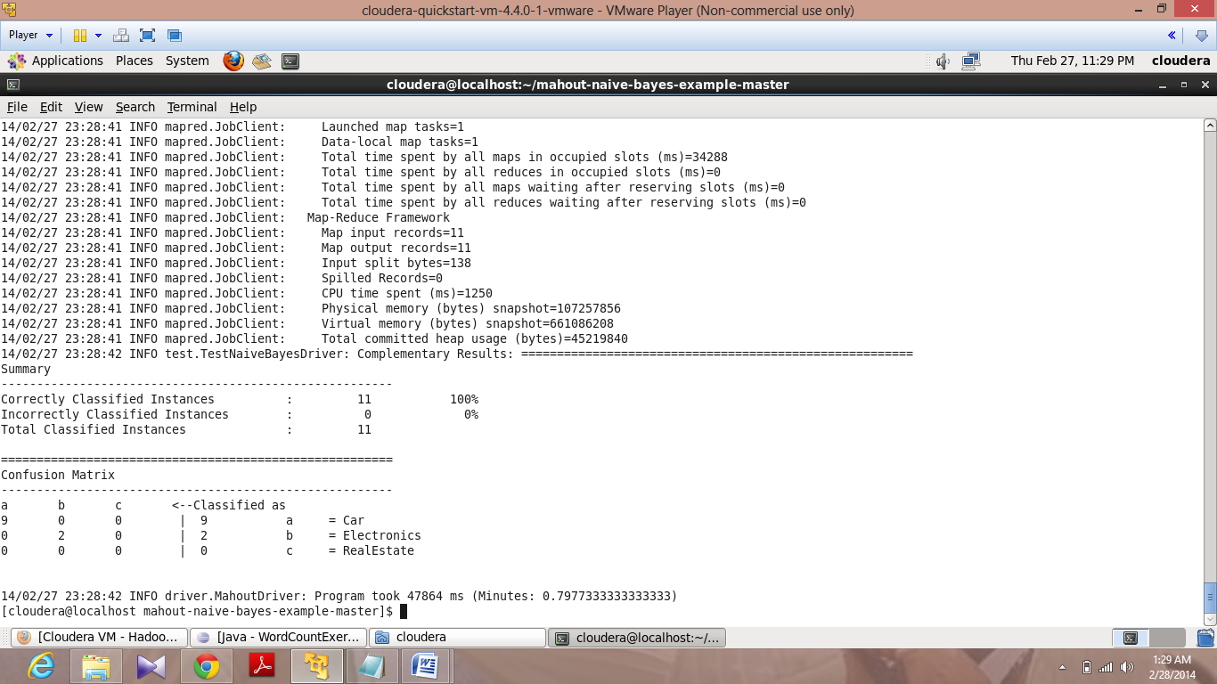

Below is output generated from my Unclassified data.

I have converted the output into .txt file and given as input to Solr

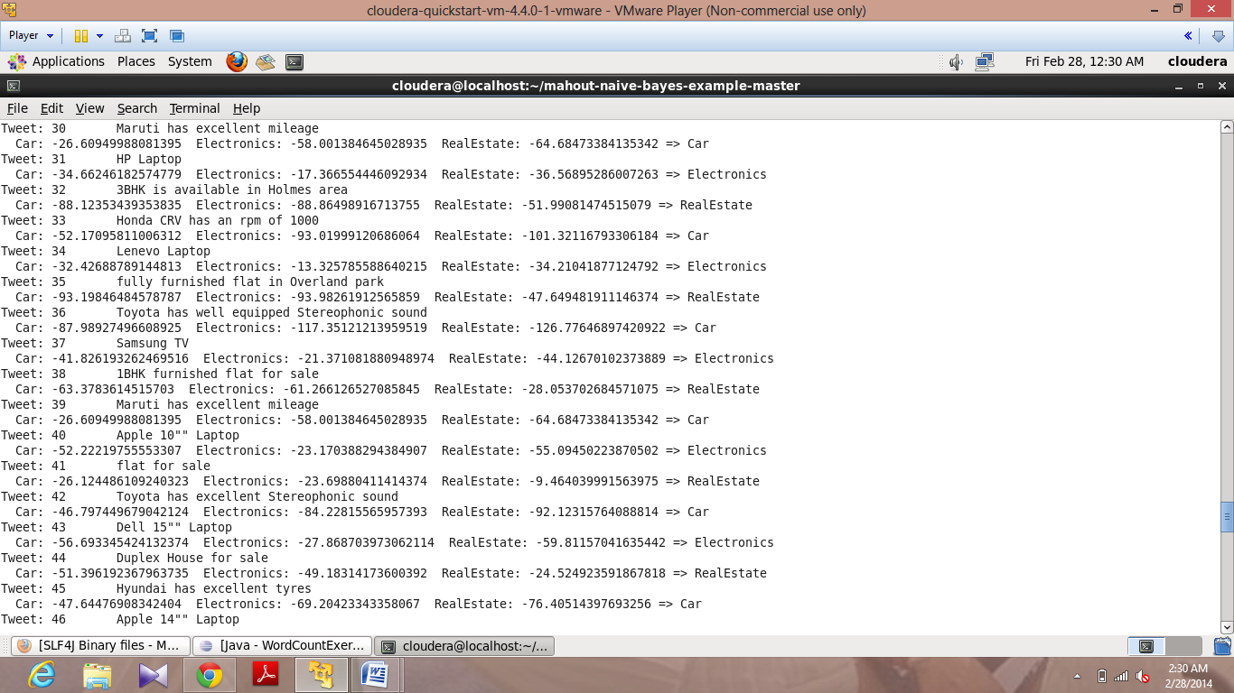

Implemented WordCount on my Test data using WordCount.jar file

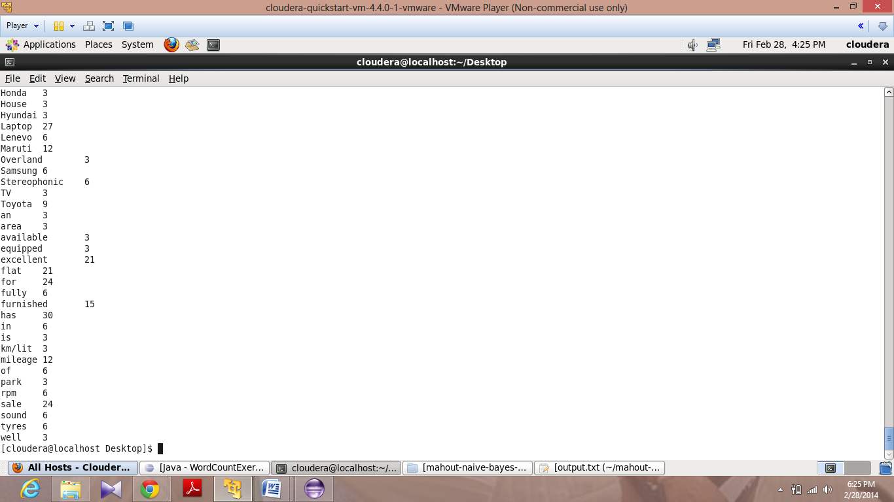

Setting up GlassFish server on cloudera

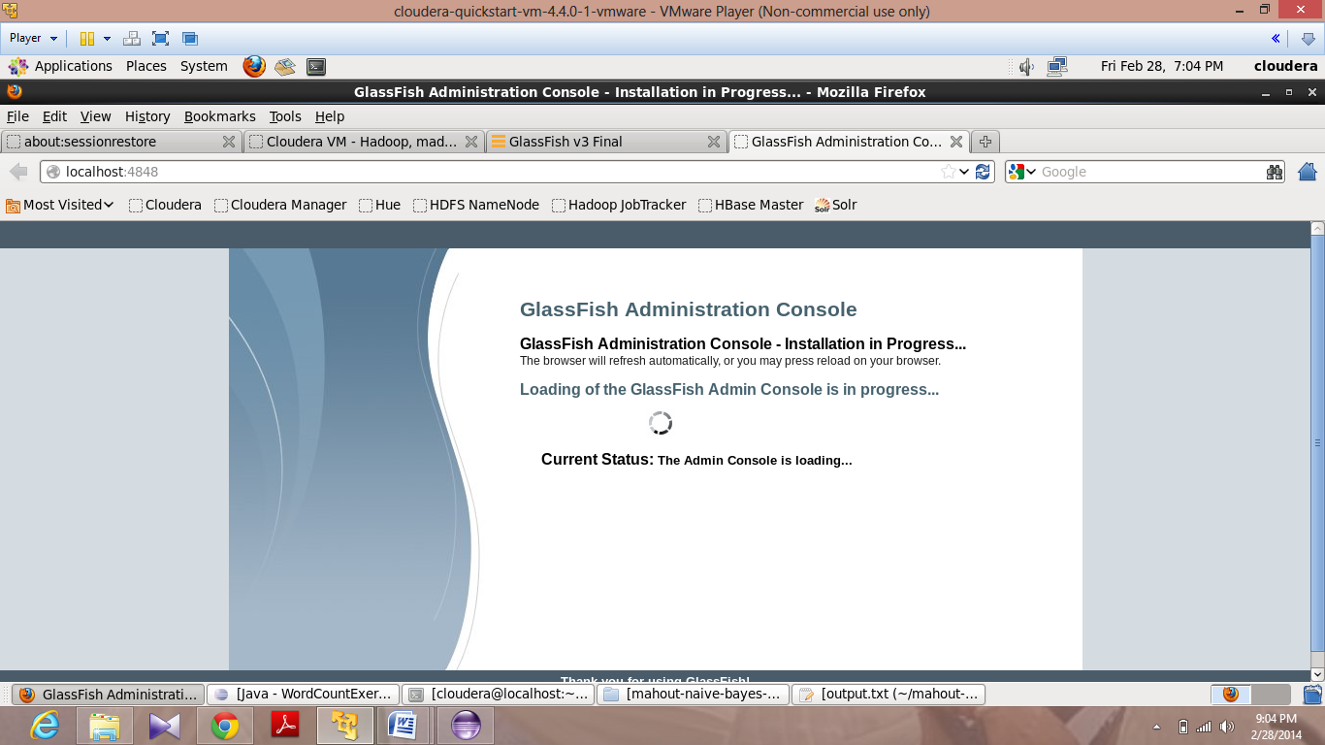

Importing Java Webservice

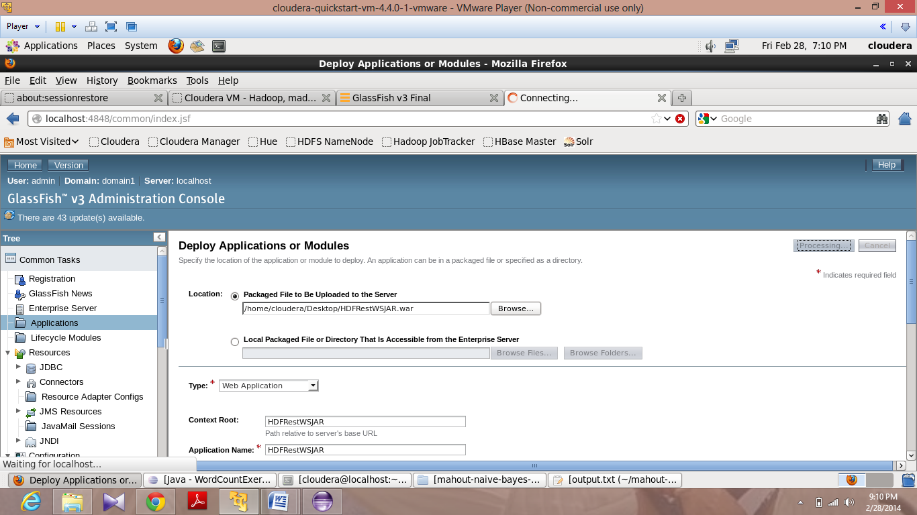

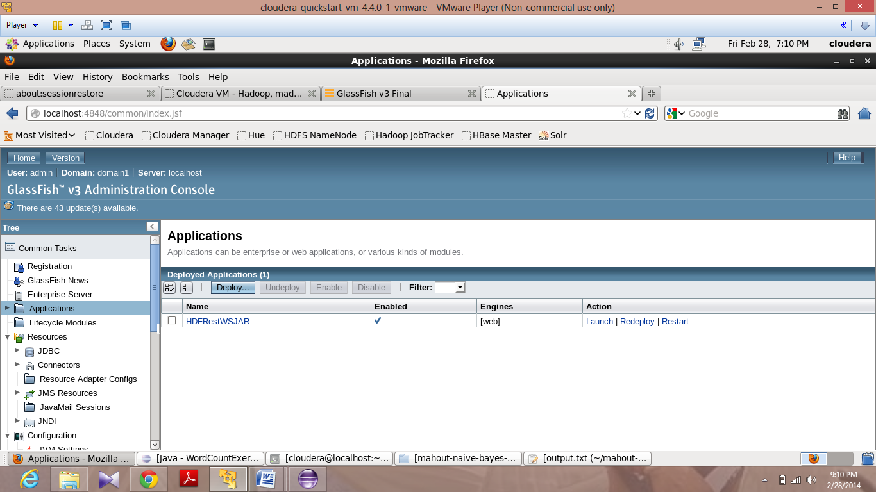

Launching of JavaWebservice

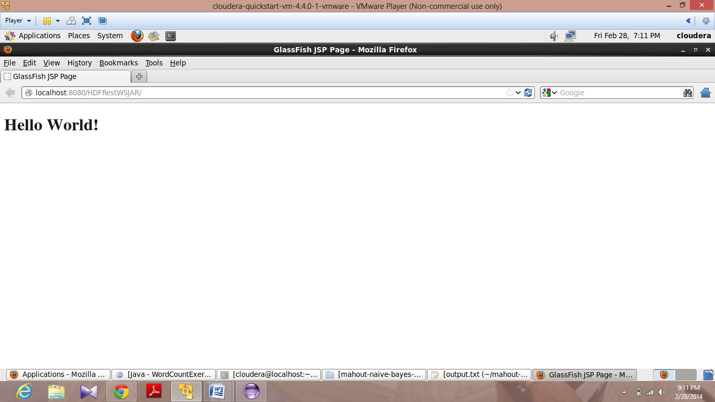

Displaying output in Hadoop through JavaRestful webservice by deploying it on GlassFish server

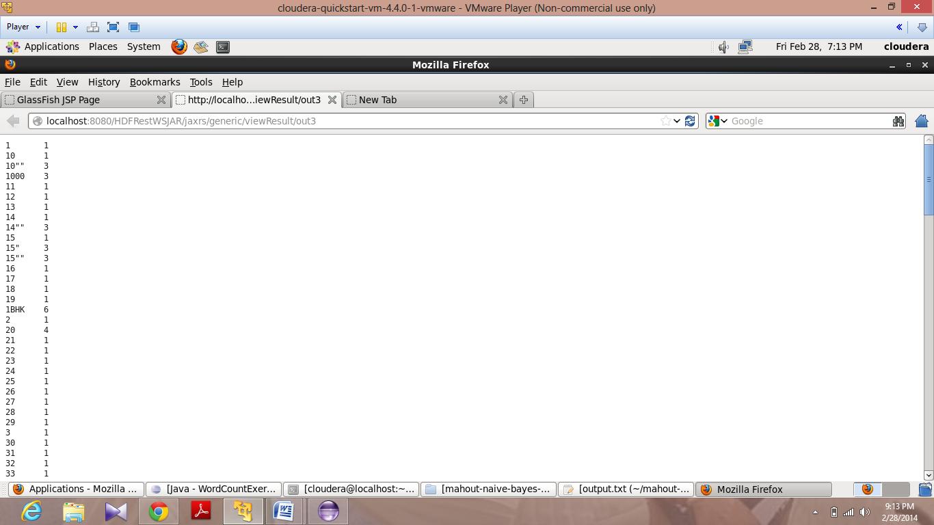

Input Data to Solr

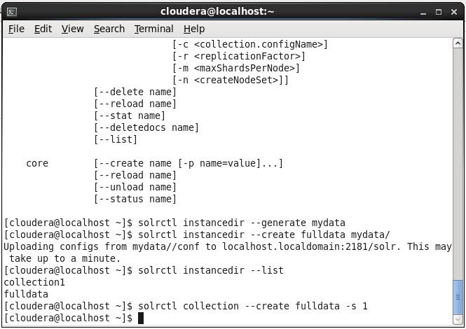

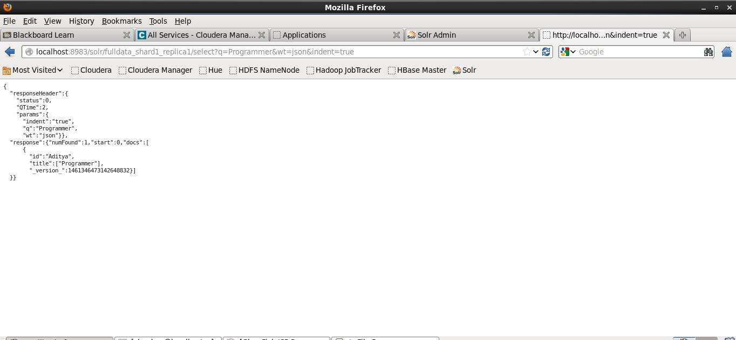

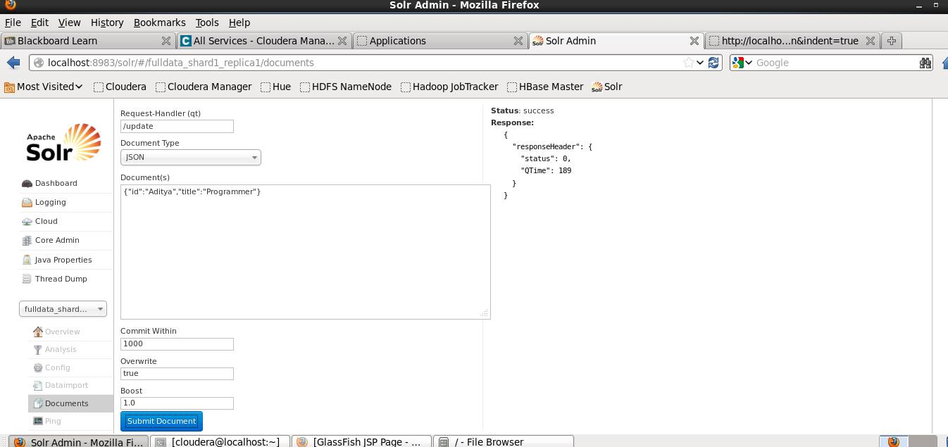

Mobile Client:

Developed Mobile client using Twitter Bootstrap CSS Framework

